Task 1

Setup a project repository in your local system, and initialize the repo using git. The project can include a simple Web application or a Microservice, developed using any programming language of your choice.

Install Flask:

Command : pip install Flask

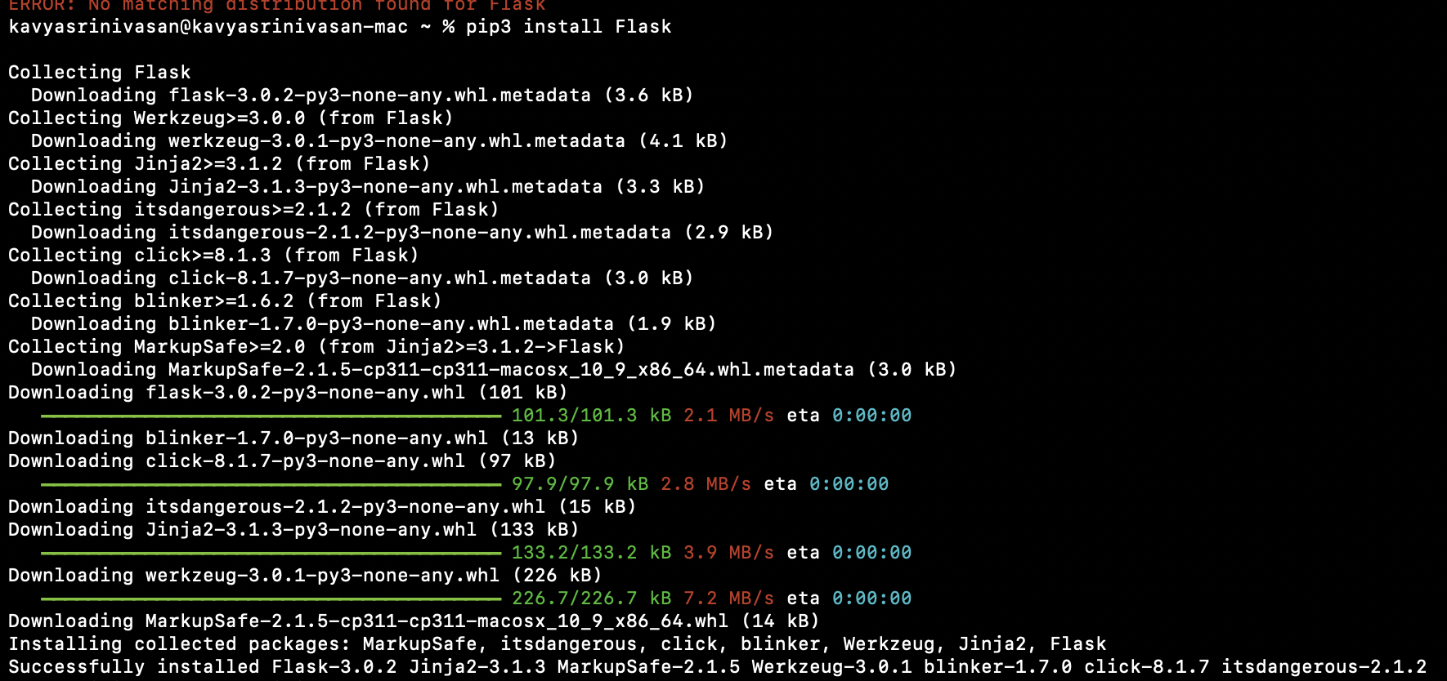

Create the Flask Application:

Create a new Python file named app.py with the following content:



from flask import Flask

# Create a Flask application

app = Flask(__name__)

# Define a route for the homepage

@app.route('/')

def index():

return 'Hello, World! This is a simple Flask web application.'

# Run the application

if __name__ == '__main__':

app.run(debug=True)

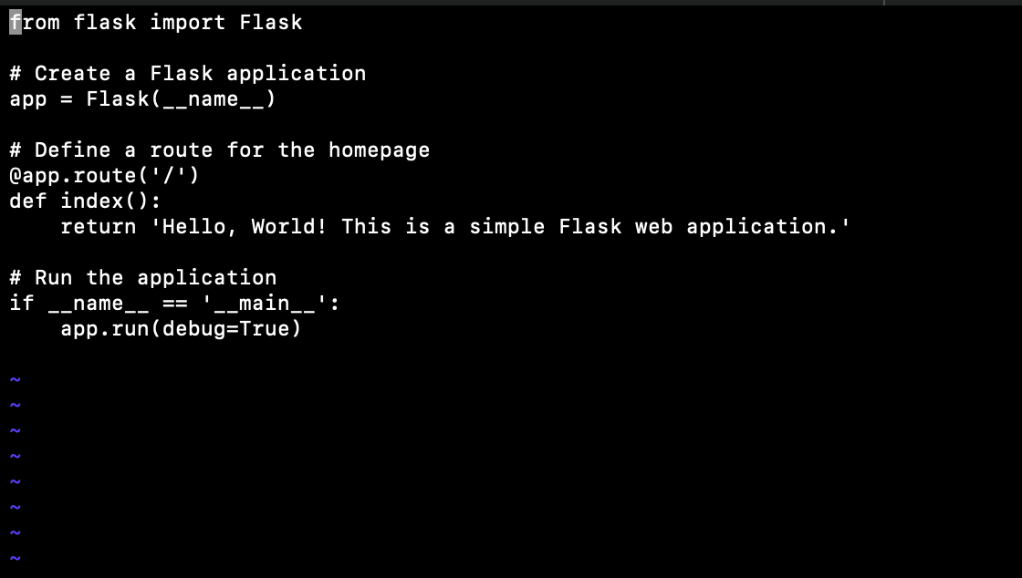

Run the Application:

Open terminal or command prompt, navigate to the directory containing app.py, and run the following command:

python app.py

This will start the Flask development server, and your application will be accessible at http://127.0.0.1:5000/ or <http://localhost:5000/>.

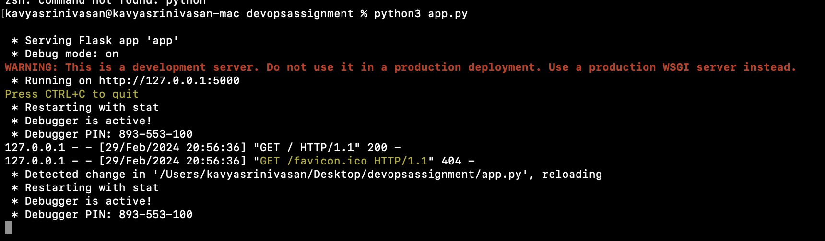

Access the Application:

Open a web browser and navigate to http://127.0.0.1:5000/ or http://localhost:5000/. The greeting message will be displayed in the browser.

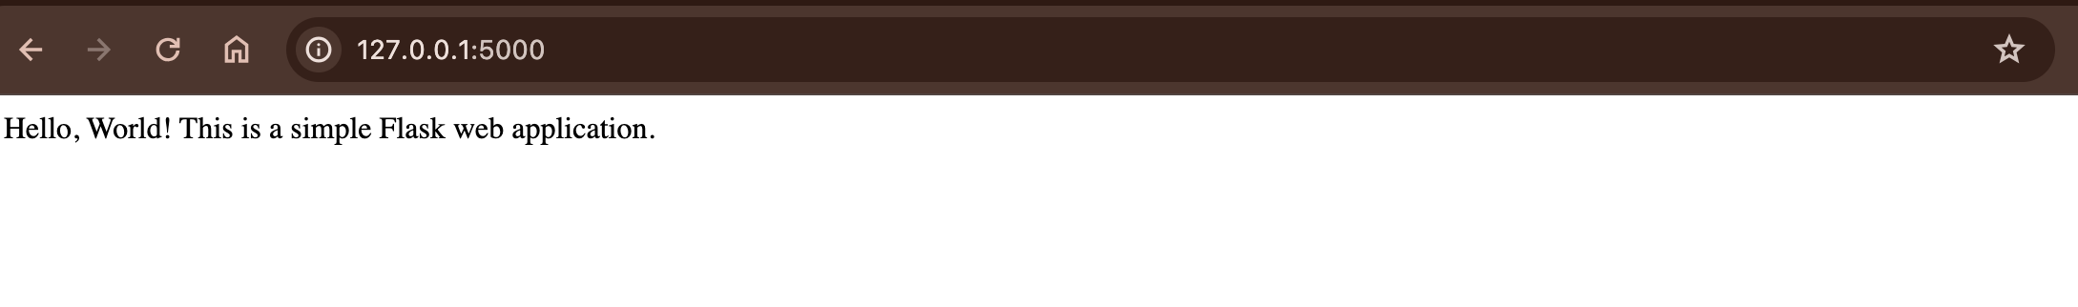

Task 2

b. Demonstrate the following git commands on the repo: init, status, add, log, commit, branch, switch, merge, stash, reset and diff.

